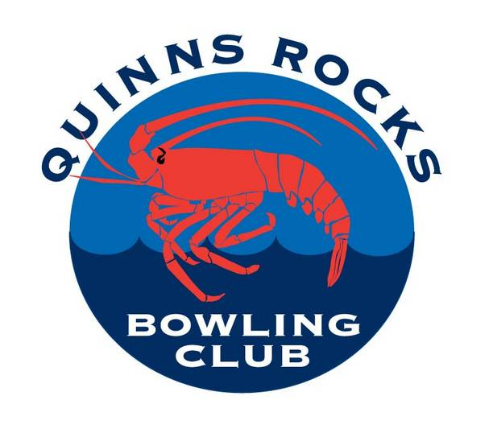
QUINNS ROCKS BOWLING CLUB
Application for Membership
Name:______________________________________________________
Address:____________________________________________________
Home Phone Number:_________________________________________
Mobile Phone Number:________________________________________
E-mail Address:_______________________________________________
Old member renewing (yes/no) Date of Birth _____/_____/________
If no any previous club played for:________________________________
You must be a financial member of the Quinns Rocks Sports Club
Quinns Rocks Sports Club Membership Number:____________________
Full Membership for the Season is $140.00 and this includes fees to Bowls WA
FULL
$140
The financial year for the club shall commence on the 1st of June and end on the 31st of May
Please Note that payment of fees prior to the end of June attracts a reduction of $20 for Full Membership.

